**HVAC MODEL DESIGNER**

A PROGRAM TO ASSIST IN HVAC DESIGNING

Table of Contents

1. Introduction…………………………………………………………………………………….…. pg. 1
2. Modes
   1. Wall Editor
      1. Create…………….………………………………………………………….……..pg. 2
      2. Edit Point………….………………………………………………………….…..pg. 5
      3. Edit Corner/Wall…………………………………………………………..…..pg. 5
      4. Delete Wall……………………………………………………………………….pg. 6
   2. Room Editor
   3. View
      1. Drag 2D…………………………………………………………………...……… pg. 3
      2. Rotate 2D…..……………………………………………………………….…… pg. 3
      3. View 3D…..………………………………………………………………….…… pg. 4
   4. Floor Picker……………………………………………………………………………….. pg. 7
   5. Zoom…………………………………………………………………………………………. pg. 8

**INTRODUCTION**

Are you thinking about designing your own HVAC system to better heat and cool your home or business? Do you want to avoid paying a contractor hundreds (if not thousands) of dollars? Then this software is for you! Allow us to introduce the HVAC Model Designer, a program that will allow you to draw your building, input some data, and obtain an accurate estimation for where heating and cooling units should be installed.

**Purpose and Scope**

This manual is intended to instruct in the use of the HVAC Model Designer software program created by Matthew French, Austin Elliott, and AJ Massey. It is not intended to be used with any other software designed. Ever.

**Organization**

This manual will be divided into sections that detail how each function works. Within each function, there may be sub-functions that will be explained. All functions will include illustrations to better assist those that just like to see pictures instead of reading the manual.

**Point of Contact**

If you have any questions, comments, or concerns about this software, please contact Nathan Bean by bombarding him with emails at: [nhbean@ksu.edu](mailto:nhbean@ksu.edu) or by calling his office several times at: (785) 532-7768 or by stalking his office at: 2216 Engineering Hall.

**MODES: WALL EDITOR - Create**

In the **HVAC Model Designer**, you will be able to create **floor plans** for every floor in your **building**. To better assist in doing that, the **HVAC Model Designer** allows the user to create **wall structures** that store data about **windows** and **doors**. The **HVAC Model Designer** starts in **CREATE MODE** by default, but you can also select **CREATE MODE** by clicking “Wall Editor -> Create Wall” in the application menu.  
  
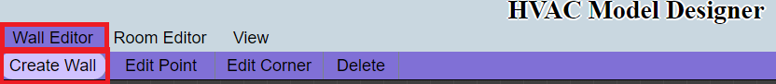  
  
 Once in **CREATE MODE**, you will be able to begin drawing lines on the **canvas** provided below. These lines will, as you draw, show you the both the **perpendicular guideline** and the **collinear guideline** for that line. In addition, if you have other lines drawn, you will see the **perpendicular** and **collinear guidelines** for the nearest point to the line you are currently drawing.  
  
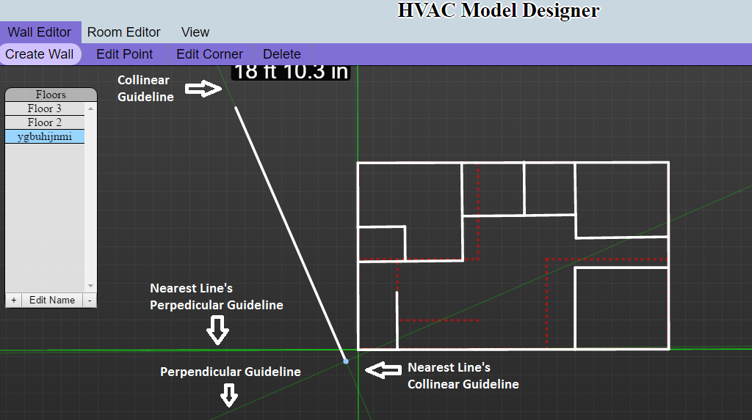

**MODES: VIEW – Drag 2D**

To use the Drag function, you will click View -> Drag 2D. The Drag option will allow you to drag the canvas behind the created structures, enabling you to see different sections of the structure.

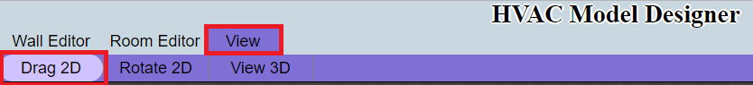

To drag the canvas, click anywhere on the canvas and then slide your mouse in the opposite direction you wish to move.

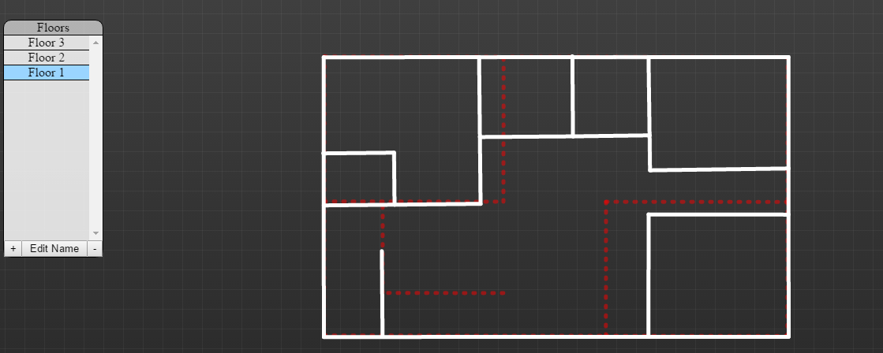

After clicking and moving the mouse to the left:

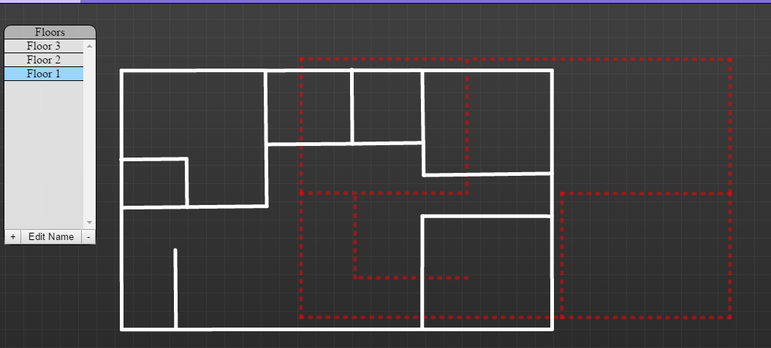

**MODES: VIEW – Rotate 2D**

To use the 2D function, you will click View -> 2D. The 2D option will allow you to rotate the structure, enabling you to see the structure from different angles.

To rotate the structure, click anywhere on the canvas and then move your mouse in the direction you wish to rotate the structure.

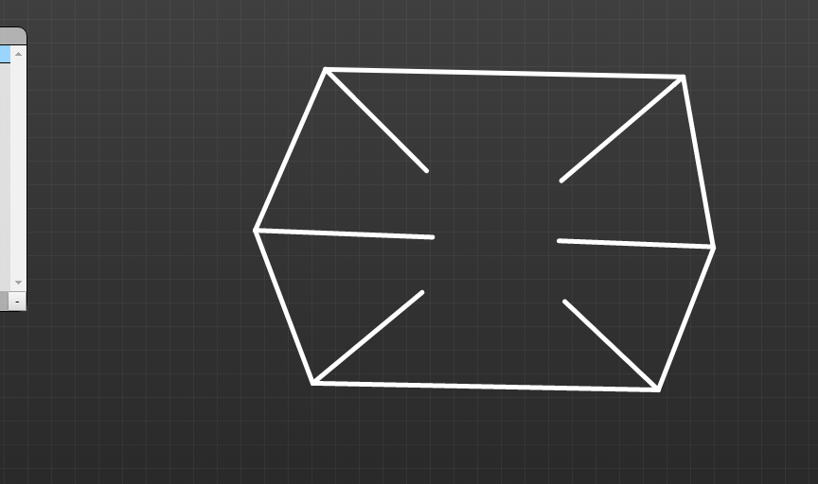

After clicking and moving the mouse to the right:

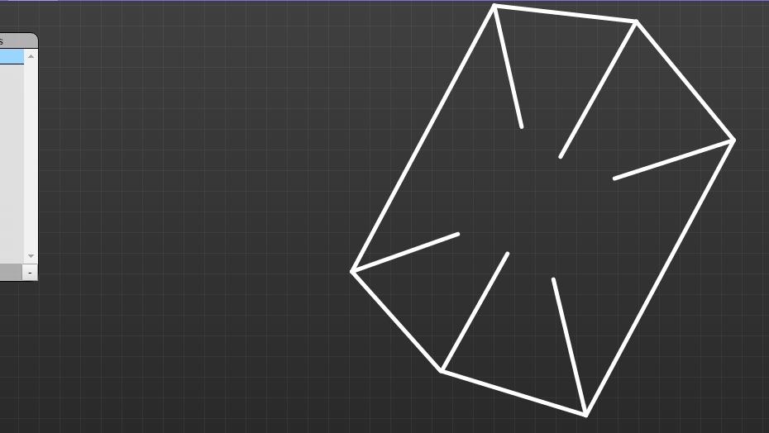

**MODES: VIEW – View 3D**

To use the 3D function, you will click View -> 3D. The 3D option will build 3D objects on top of the structure you have created, enabling you to see the structure from a 3D perspective.

Once in 3D MODE, more options will be made available to you. The first is the 3D Drag option.

3D Mode starts off in the 3D Drag option, but you can also select this option by clicking View -> 3D -> Drag. When 3D Drag is selected, you will be able to move the structure by clicking anywhere on the canvas and moving the mouse in the direction you want to move the structure.

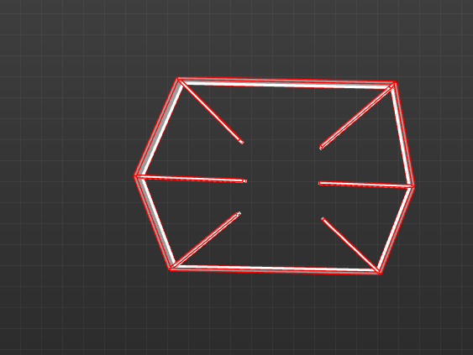

After clicking and moving the mouse to the left:

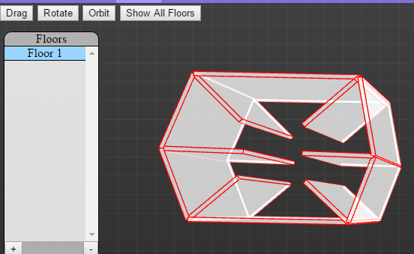

The next 3D option is Rotate. This option will allow you to rotate the 3D structure to see the structure from different angles. To use the 3D Rotate option, click View -> 3D -> Rotate.

When 3D Rotate is selected, you will be able to click anywhere on the canvas and rotate the 3D structure in the direction you move your mouse.



After clicking and moving the mouse to the left:

